**A comparison of modelled and observed wave spectra during the High Wind Gas Exchange Study**

Ian M. Brooks1, Sophia E. Brumer2, Christopher J. Zappa2, John Prytherch1, Robin W. Pascal3, H. Tamura4, Ludovic Bariteau5, Byron Blomquist5, Christopher W. Fairall5

1 School of Earth and Environment, University of Leeds, Leeds, UK

2 Lamont-Doherty Earth Observatory, Columbia University, New York, USA

3 National Oceanography Centre, Southampton, UK

4 Port and Airport Research Institute, Japan

5 NOAA Earth System Research Laboratory, Boulder, Colorado, USA

**Abstract**

**Introduction**

Wind driven waves on the ocean surface mediate many interactions between the ocean and atmosphere. They act as roughness elements that control the surface drag and transfer of momentum from the wind to the ocean (Charnock, 1955); breaking waves generate sea spray aerosol from the bursting of bubbles (de Leeuw et al. 2011) providing one of the largest sources of aerosol mass to the atmosphere; and gas transfer between these bubbles and the surrounding water in the upper ocean is thought to be a major contribution to gas transfer at high wind speeds for gases of low solubility (Wanninkhof et al. 2009).

Most parameterisations of the gas transfer velocity for have been formulated solely in terms of wind speed; however, observational studies for CO2 have found the wind speed dependence to vary roughly between quadratic and cubic, leading to very large uncertainties at high wind speeds. The discrepancies between studies are widely assumed to result from differences in the bubble-mediated flux under different wind-wave regimes. Models of the bubble mediated contribution to the gas transfer velocity have been proposed using the surface whitecap fraction as a proxy for the bubbles (Asher et al. 2002, Woolf, 2005); the Woolf (2005) model is incorporated within the NOAA COAREG 3.1 bulk air-sea flux algorithm (Fairall et al. 2011).

Whitecaps have also generally been parameterised as functions of wind speed, 30 different functions spanning at least 2 orders of magnitude at any given wind speed are summarised by Angeulova and Webster (2006). The very wide variability between functions results in large part from differences in the methods used as well as different wind-wave regimes. Among recent measurements there is substantially greater agreement; nevertheless wave state has been demonstrated to have a significant influence whitecap fraction by a number of studies (Stramska and Petelski, 2003; Sugihara et al. 2007; Lafon et al., 2007; Callaghan et al. 2008; Goddjin-Murphy et al. 2011; Salisbury et al., 2013). Several studies have used a Reynolds number to account for the effects of both wind and waves on wave breaking and whitecaps (Toba and Koga, 1986; Zhao and Toba, 2001; Goddjin-Murphy et al. 2011); Recently Norris et al. (2013) demonstrated that a Reynolds number accounted for up to twice the variance in direct measurements of the sea spray aerosol flux – generated by bubble bursting in whitecaps – as did wind speed alone. Brumer et al. (2017) found that use of a Reynolds number instead of wind speed alone, reconciled the gas transfer velocity measurements from two different field campaigns where the wind-speed functions differed substantially.

In spite of their importance to physical exchange processes, wave properties have rarely been measured during in situ studies of air-sea exchange. The ideal is a direct measurement of the directional wave spectra, for example from a wave buoy. Wave radar provide retrievals of directional spectra, but do not directly measure the wave height, which must be inferred from relationships between spectral shape and wave height and can be in error under conditions where the underlying assumptions are invalid [refs, more detail?]. Direct measurements of one dimensional spectra can be obtained from ship-borne systems such as the Ship Borne Wave Recorder (Tucker and Pitt, 2001) or surface displacements measurements corrected for ship motion (Christensen et al. 2013; Cifuentes-Lorenzen et al. 2014); however, such measurements are generally only reliable when the ship is on station, suffering from both increased ship motion and Doppler shifting of the spectrum when the ship is underway. It is possible to attempt corrections for the Doppler shift (Cifuentes-Lorenzen et al. 2014), but this requires knowing the relative directions of the waves to the ship heading, information that is not directly available from the measurements. In the absence of in situ measurements, wave models provide a potential source of information on wave state, and the option of generating wave spectra for past field campaigns by forcing the wave model with archive reanalyses of the meteorological forcing conditions. Wave models also allow filling in periods when direct measurements are missing or unreliable. In order to apply information from wave models to the analysis of air-sea exchange processes, we must have confidence in the validity of the modelled spectra.

The High Wind Gas Exchange Study (HiWinGS, Yang et al. 2014, Brumer et al. 2017) was designed to study the exchange of gases between the ocean and atmosphere under high wind conditions, and in particular to determine the impact of wave state and bubble populations on gas transfer. An important part of the study was the measurement of the surface wave field alongside direct eddy covariance estimates of the flux, and transfer velocities, of multiple gases. Here we provide an overview of the wave state throughout the HiWinGS cruise, and the relevant wave statistics and their breakdown into contributions from the wind-sea and swell. In situ measurements of the directional spectra were made during periods when the ship was hove to on station. When underway we rely on modelled wave spectra; the performance of the wave model is evaluated against the direct measurements when on station.

**Wave Measurements**

The HiWinGS cruise took place between October 8 and November 13 2013 on the RV Knorr, departing from Nuuk, Greenland and ending at Woods Hole, Massachusetts, with the majority of measurements being made close to the boundary between the Labrador Sea and North Atlantic, immediately south of Greenland (Fig 1). The location and time of year were chosen to maximise the likelihood of sampling high wind and wave conditions within storm systems coming off the coast of Canada. The focus on direct measurements of air-sea fluxes via the eddy covariance technique determined the sampling strategy – prior to the arrival of each storm system the ship was positioned in the region of maximum forecast winds; it then sat on station with bow to wind making measurements until the storm had past.

Continuous wave measurements were made with Riegl DL90 laser ranger mounted on the foremast; this provided a 10 Hz measurement of surface vertical displacement after the raw signal was corrected for ship pitch, roll, and motion following (Cifuentes-Lorenzen et al. 2014). 1-dimensional wave spectra were then calculated. During each of the measurement stations a Datawell DWR-G4 directional waverider buoy was deployed. The waverider is a 0.4m diameter, spherical buoy that follows wave motions on scales larger than itself. It uses the Doppler shift of the carrier signal from Global Positioning System (GPS) satellites to determine its motion in three dimensions, from which the directional wave spectrum can be calculated. Herbers et al. (2012) found spectra from the DWR-G4 to compare well with older, and larger, models of the waverider that use inertial motion units to determine their motion, but that in high seas water washing over the GPS patch antenna could result in the intermittent loss of the signal from the GPS satellites. A subset of the waverider’s measurements is transmitted via radio to the ship for near real-time monitoring, with the full time series of raw displacements being saved on the buoy, along with 30-minute average wave spectra and statistics.

The waverider was allowed to drift freely during most deployments, with the ship moving slowly to keep it within radio reception range – this was limited to approximately 5 kilometres during HiWinGS, but can be much further depending upon antenna location and environmental conditions. On two occasions the buoy was deployed tethered to the ship on 200 m of polypropylene rope. Provided the tether remained slack and the ship maintained a relative position that avoided sheltering the buoy from oncoming waves, this does not impact the measurements in any way, being essentially equivalent to a fixed deployment in shallow water where the buoy is moored to the sea bed. The first of the tethered deployments was the initial deployment (station 1), during which restrictions imposed by other ship operations meant that we wished to keep the waverider close to the ship; the second was during the largest storm (station 4), when wind and wave conditions were predicted to be severe enough that the ship would be unable to follow the buoy as it drifted. Data quality was generally good throughout all deployments except during the large storm, where at its peak the ship was unable to maintain a relative position that kept the tether slack, and the buoy was intermittently dragged beneath wave peaks by, losing GPS reception. Data periods contaminated by the temporary loss of GPS reception have been excluded from the analysis.

The waverider measures time series of its displacement in the vertical and to the North and West at a sample frequency of 1.28 Hz, and calculates directional spectra and 1-dimensional wave statistics on 30-minute intervals. Here we calculate directional spectra directly from the raw displacement time series; this allows exact time matching of wave spectra to other measurements. To derive the directional wave spectra we utilise the Extended Maximum Likelihood Method (Hashimoto et al. 1993) as implemented in the DIWASP (v1.4) toolbox for MATLAB (Johnson, 2012). The directional spectra are calculated with a resolution of 1° by 0.005 Hz and a frequency range of 0.04 to 0.64 Hz. In initial tests spurious spectral peaks sometimes occurred at very low frequencies (periods of 10s of seconds). These are presumed to result from integration of low frequency noise or bias signals in the waverider’s velocity measurements. Although they contribute negligibly to the energy of either the total or swell component of the wave state, we suppress them by high-pass filtering the displacement time series before calculating the spectra using a pass-band frequency of 0.05 Hz, stop-band frequency of 0.04 Hz, and a cosine roll-off between the two.

**The Wave Model**

The third generation WAVEWATCH-IIITM model, version 3.14 [WW3; Tolman, 2009] was used to compute a wave hindcast for the duration of the cruise from October 1 to November 15, 2013 (2.5 months). The model domain was set to cover the North Atlantic spanning from the Equator to 70ºN and from 100ºW to 15ºE with a horizontal grid resolution of 0.2 degrees in both latitude and longitude. Bottom topography and coastlines were taken from the ETOPO2 data set that provides 2 minute gridded elevations/bathymetry for the world. The wave model was forced by 6-hourly surface wind fields from the National Centers for Environmental Prediction/Climate Forecast System Reanalysis (NCEP/CFSR) product [Saha *et al*., 2010] in which has a horizontal resolution of ~38km (Gaussian Grid: T382).

WW3 solves the wave spectral balance equation which expresses the evolution of the wave field as a sum of source terms consisting of the energy transferred to the waves by the wind ${(S}_{in}$), the energy lost through dissipation due to wave breaking ($S_{dis }$) and nonlinear wave-wave energy transfers ($S_{nl}$):

 (1)

where *N* is the wave action density spectrum, *S* the source terms, and σ the intrinsic (radian) frequency.

The source terms proposed by Tolman and Chalikov's [1996] were used for the hindcast and the surface wind speed at 10 m elevation (*U*10) were modified to account for the instability of the atmospheric boundary layer (the “effective” wind speed; Tolman, 2002). Being a third generation model, WW3 allows for a punctual, although approximate, representation of $S_{nl}$ for which the discrete interaction approximation (DIA) method was chosen [Hasselmann et al. 1985]. For spatial propagation of the wave spectrum, the default third-order advection scheme was used.

The spectral space was discretized using 35 frequencies ranging from 0.0412 Hz to 1.05 Hz (relative frequency of 10%, *f*m+1 = 1.1*f*m, where m is a discrete grid counter) with 36 directions (*Δθ* = 10°). We assumed an *f*−5 spectral tail outside the model frequency range, as used in the default WW3 settings. The directional wave spectra from the hindcast were stored every 30 minutes along 4 trajectories on the model grid points surrounding each point along the ship’s track; these are then averaged to provide a single model spectrum representative of the ship’s location.

**Wave Spectra Partitioning**

There have been many schemes proposed to separate the wind sea and swell components of the wave spectrum; none are perfect, and there is little consensus on the best approach. [*add background*]

It is perhaps inevitable that any definition based on identifying thresholds of frequency and direction for a single spectra will fail on some borderline cases, particularly for measured spectra, which are usually noisy, may be non-stationary, and for which small changes in the averaging period can result in changes in spectral peak frequency and direction sufficient to alter their classification.

We partition the directional spectrum into wind sea and swell components following the general approach of Hanson and Phillips (2001) and Portilla et al. (2009). The spectra are divided up into an arbitrary number of wave groups using an inverted watershed algorithm (Portilla et al., 2009; Hanson and Jensen, 2004) which associates each point in the spectrum with a local peak. The observational spectra can be very noisy and generate a large number of wave groups. Portilla et al. (2009) reduced these by first smoothing the spectrum, effectively applying a 3×3 element average around each spectral estimate. Hanson and Jensen (2004) used a slightly different approach, applying an 8-point connected smoothing transform around each spectral estimate to remove local peaks less than some threshold value. We combine these approaches, first applying a 3x3 element averaging kernel around each point, then removing remaining local peaks less than threshold of 1.5% of the spectral maximum. This usually results in fewer than 10 discrete wave groups being returned. We then combine any wave group contributing less than 8% of the total spectral energy with the group with a peak closest to its own. Finally we partition all the remaining wave groups into wind sea and swell using the wave age criterion of Hanson and Phillips (2001):

, (2)

Where *c*p is the phase speed at the peak frequency of the wave group, *U*10 is the 10-m wind speed, and *δ* is the angle between the directions of the wind and the peak of the wave group. This is reformulated in terms of the peak frequency, *f*p, for deep water waves:

. (3)

Hanson and Phillips (2001) note that the factor of 1.5 is generous, but ensures that all possible wind sea peaks are identified. Since our primary concern is the influence of wave breaking on air-sea gas exchange, a process dominated by the wind sea, we group all wind sea and all swell systems together to give a single group of each. In order to maintain consistency for both observed and modelled spectra, we apply the same processing to the 2D spectra from WAVEWATCH-III, to generate single wind wave and swell groups for the same periods as for the observed spectra. The modelled spectra extend to higher frequencies than the waverider, and are truncated to match prior to calculating wave spectral statistics.

An example of directional spectra from the waverider and WAVEWATCH-III are shown in Figure AA2; the grey shaded area indicates the Hanson and Phillips (2001) criteria for spectral peaks associated with wind seas. In this case both a small wind sea and a swell are identified in the observed spectrum, while only the swell is indentified in the modelled spectrum. There is close agreement in both the location (in frequency and direction) and magnitude of the swell peak.

**Wave Field Statistics**

The observed mean wind and wave conditions (30 minute averages of 10-m neutral wind speed (U10­) and direction, and significant wave height (Hs)) for the duration of the HiWinGS cruise are shown in Figure 2 along with the corresponding values from WAVEWATCH-III. The model values are the mean of the 4 grid points surrounding the ship position at each sample time. There is good agreement between the wind forcing in the model and the observed values, although the observations are more variable and there are small discrepancies in both magnitude and timing of the main features.

**1-Dimensional Spectra and Statistics**

The significant wave height is similarly in good general agreement, although the model typically underestimates the peak wave heights and shows greater discrepancies in timing than is evident in the winds – for example during station 3 (DoY 291.75-294.6) where the model lags the measurements by 2-3 hours during both rising and falling wave heights, while closely matching the peak values. The mean difference is just 0.28 m, or 6% when normalised by the measured Hs. The WW3 significant wave heights are plotted against the waverider measurements in Figure AA. The generally good agreement, but tendency to underestimate the largest significant wave heights is clear. There are 6 distinct outliers where the model Hs is very low compared to the observations. These are consecutive points over a 3-hour period around DoY 298.5. At this time there is a rapid shift in wind direction of approximately 180°, and a temporary drop in wind speed, before a rapid increase to the maximum values observed during the cruise. The shift in wind is accompanied by a temporary drop in wave height within WW3, while no reduction in the measured wave height is observed. In order to check for differences in behaviour for rising/falling winds, corresponding to actively growing wind seas and unforced swells, we partition the data into rising/falling/steady winds using a 3-hour running mean of wind speed, and threshold values of ±0.1 m s-1 per 30-minute interval to define the category boundaries. No obvious differences in behaviour are evident.

Figure BB shows the total spectral energy from WW3 and the waverider – generally similar to Hs [could omit this one?].

Figures CC and DD show the spectral energy density and period at the peak of the 1-dimensional spectra. WW3 tends to underestimate both the peak energy density (mean normalised difference = 24.5%) and the peak period (mean normalised difference = 10.8%). The peak energy density shows a greater tendency to be underestimated by the model during rising winds (85% of data points, mean difference = -33%) than falling (75% of data points, mean difference = -21%) or steady winds (77% of data points, mean difference = -24%).

Typical spectra close to the peak of a storm are shown in Figure EE. There is good agreement in spectral energy density at frequencies above the spectral peak, but the observed spectral peak is at slightly higher energy, and lower frequency, than that of the wave model. The slightly elevated spectral energy at the lowest frequencies of the waverider spectrum is spurious and results from integration of small low-frequency noise or bias signals in the waverider’s velocity measurements; however is contributes negligibly to the total spectral energy, spectral moments and wave statistics. The low frequency limit of the WW3 spectra varies with the wave state.

**Directional Wave Spectra and Statistics**

The directional wave spectra are used to determine separate wind sea and swell partitions – either or both may exist in each spectral estimate; an overview is provided by time series of the significant wave heights from each in Figure FF. There is broad agreement between the model and observations on *H*s for both wind sea and swell; as for the 1-dimensional spectra the observations show greater scatter than the model. There are, however, extended periods when identification of which partitions exist differs between the observed and modelled spectra. For example, in the decaying phase of the storm during station 3 (from DoY 293.5 onwards), both a wind sea and swell are identified in the observations, but only a swell is identified in the model spectra. The observed and modelled *H*s values for wind seas and swell are compared in Figure GG for those periods where they are identified in both data sets. In both cases the data scatter broadly about the 1:1 line, with a standard deviation of approximately 1 m (0.95 m for wind seas, 1.02 m for swell). In the case of swells, there are some cases where the model drastically underestimates the measured *H*s during falling winds. For wind seas, the model underestimate *H*s for larger values (*H*s > ~5 m) during rising winds, similar to the findings from the 1-dimensional spectra.

Energy densities at the spectral peaks for wind sea and swell are shown in Figure HH. In contrast to the 1-dimensional spectra, where the model tended to underestimate the observed peak energy, for both the wind seas and swell the model tends to have a higher energy than the observations at the peak of the directional spectrum. This implies a difference in directional spreading of observed and modelled spectra.

The peak periods are shown in figure II

Peak directions are shown in figure JJ.

The 2-dimensional spectral spreading for wind sea and wave partitions is shown in Figure KK. There is a clear difference in behaviour between the two – for wind seas the model usually underestimates the spread compared to the observations, while for swell it tends to overestimate the spreading. [*1D spectra are usually a close match a f > fp* *and model drops off faster at low frequency. Suggest it is directional spread where the major difference lies...calculate that too*]

**Conclusions**

**Acknowledgements**

This work was funded by the National Science Foundation (Grants OCE-0647667 and OCE-1537890), the National Oceanic and Atmospheric Administration (Grant NA07OAR4310094), and the Natural Environment Research Council (grants NE/J020893/1 and NE/J020540/1). We would like to thank the captain and crew of the R/V Knorr for their support throughout the cruise. The authors thank the NERC Earth Observation Data Acquisition and Analysis Service (NEODAAS) for supplying data used for operational planning throughout the cruise.

**References**

Asher, W., Edson, J., McGillis, W., Wanninkhof, R., Ho, D. T., and Litchendor, T.: Fractional area whitecap coverage and air-sea gas transfer velocities measured during GasEx-98, *in: Gas Transfer at Water Surfaces, American Geophysical Union*, 199-203, 2002.

Brumer, S. E., C. J. Zappa, I. M. Brooks, H. Tamura, S. M. Brown, B. Blomquist, C. W. Fairall, A. Cifuentes-Lorenzen, 2017: Whitecap coverage dependence on wind and wave statistics as observed during SO GasEx and HiWinGS, *J. Phys. Oceanogr*. (submitted)

Callaghan, A. H., G. B. Deane, and M. D. Stokes, 2008: Observed physical and environmental causes of scatter in whitecap coverage values in a fetch-limited coastal zone, J. Geophys. Res., 113, C05022, doi:10.1029/2007JC004453.

Christensen, K. H., J. Röhrs, B. Ward, I. Fer, G. Broström, Ø. Saetra, Ø. Breivik, 2013: Surface wave measurements using a ship-mounted ultrasonic altimeter. *Methods in Oceanogr.* 6, 1-15, doi: 10.1016/j.mio.2013.07.002

Cifuentes-Lorenzen, A., Edson, J. B., Zappa, C. J., Bariteau, L.: A multisensory comparison of ocean wave frequency spectra from a research vessel during the Southern Ocean Gas Exchange Experiment, *J. Atmos. Oceanic Technol.*, 30, 2907-2925, doi:10.1175/JTECH-D-12-00181.1, 2014.

de Leeuw, G., E. L. Andreas, M. D. Anguelova, C. W. Fairall, E. R. Lewis, C. D. O’Dowd, M. Schulz, S. E. Schwartz, 2011: Production flux of sea spray aerosol, *Rev. Geophys.,* 49, doi: 10.1029/2010RG00349

Drennan, W. M., H. C. Graber, D. Hauser, and C. Quentin, 2003: On the wave age dependence of wind stress over pure wind seas, *J. Geophys. Res.*, 108(C3), 8062, doi:10.1029/2000JC000715,

Donelan, M. A., J. Hamilton, and W. H. Hui, Directional spectra of wind generated waves, Philos. Trans. R. Soc. London, Ser. A, 315, 509–562, 1985.

Fairall, C. W., M. Yang, L. Bariteau, J. Edson, D. Helmig, W. McGillis, S. Pezoa, J. Hare, B. Huebert, and B. Blomquist, 2011: Implementation of the coupled ocean-atmosphere response experiment flux algorithm with CO2, dimethyl sulfide, and O3, J. Geophys. Res., 116, C00F09, doi:10.1029/2010JC006884.

Goddijn-Murphy, L., Woolf, D. K., and A. H. Callaghan, A. H.: Parameterizations and algorithms for oceanic whitecap coverage, J. Phys. Oceanogr., 41, 742–756, doi:10.1175/2010JPO4533.1, 2011.

Hanson, J. L. and O. M. Philipps, 2001: Automated Analysis of Ocean Surface Directional Wave Spectra, *J. Atmos. Ocean. Technol.*, 18, 277-293

Hanson, J. L., and R. E. Jensen, 2004: Wave system diagnostics for numerical wave models. *Proc. Eighth Int. Workshop on Wave Hindcasting and Forecasting, Oahu, HI, Joint WMO/IOC Technical Commission for Oceanography and Marine Meteorology Tech. Rep. 29, WMO/TD-1319*, 19 pp. Available at: <http://www.waveworkshop.org/8thWaves/Papers/E3.pdf>, last access 15 March 2017.

Hashimoto, N., T. Nagai, and T. Asai, 1993: Modification of the extended maximum entropy principle for estimating directional spectrum in incident and reflected wave field. *Rept. Of P.H.R.I.* **32**(4) 25-47.

Hasselmann, S., K. Hasselmann, J. H. Allender, and T. P. Barnett (1985), Computations and parameterizations of the nonlinear energy transfer in a gravity-wave spectrum. Part II: Parameterizations of the nonlinear energy transfer for application in wave models, J. Phys. Oceanogr., 15, 1378–1391.

Johnson, D., 2012: DIWASP, a directional wave spectra toolbox Version 1.4 for MATLAB®: User Manual. Research Report WP-1601-DJ (V1.1), Centre for Water Research, University of Western Australia. Available at: https://github.com/metocean/diwasp/blob/master/DIWASP_manual.pdf, last access 4 January 2017.

Lafon, C., J. Piazzola, P. Forget, and S. Despiau (2007), Whitecap coverage in coastal environment for steady and unsteady wave field conditions, J. Mar. Syst., 66(1–4), 38–46, doi:10.1016/j. jmarsys.2006.02.013

Norris, S. J., Brooks, I. M., and Salisbury, D. J.: A wave roughness Reynolds number parameterization of the sea spray source flux, Geophys. Res. Letts. 40, 1-5, doi:10.1002/grl.50795, 2013.

Pascal, R. W., Yelland, M. J., Srokosz, M. A., Moat, B. I., Waugh, E. M., Comben, D. H., Cansdale, A. G., Hartman, M. C., Coles, D. G. and Chang Hsueh, P.: Spar buoy for high-frequency wave measurements and detection of wave breaking in the open ocean, *J. Atmos. Oceanic Technol.,* 28, doi: 10.1175/2010JTECHO764.1, 2011.

Portilla J., F. J. Ocampo-Torres, and J. Monbaliu, (2009), Spectral Partitioning and Identification of Wind Sea and Swell, *J. Atmos. Ocean. Technol.*, 26, 107-122.

Saha, S., Moorthi, S., Pan, H.-L. et al (2009), The NCEP climate forecast system reanalysis. Bull. Amer. Meterol. Soc. 91, 1015–1057, doi: 10.1175/2010BAMS3001.1

Salisbury, D. J., Anguelova, M., and Brooks, I. M.: On the variability of whitecap fraction using satellite-based observations, J. Geophys. Res., 118, 1-22, doi:10.1002/2013JC008797, 2013.

Stramska, M., and T. Petelski (2003), Observations of oceanic whitecaps in the north polar waters of the Atlantic, J. Geophys. Res., 108(C3), 3086, doi:10.1029/2002JC001321.

Sugihara, Y., H. Tsumori, T. Ohga, H. Yoshioka, and S. Serizawa (2007), Variation of whitecap coverage with wave-field conditions, J. Mar. Syst., 66, 47–60, doi:10.1016/j.jmarsys.2006.01.014.

Toba, Y., and Koga, M.: A parameter describing overall conditions of wave breaking, whitecapping, sea-spray production and wind stress, in Oceanic Whitecaps, edited by E. C. Monahan and G. Mac Niocaill, pp. 37–47, Springer, New York, 1986.

Tolman, H. L., and D. V. Chalikov (1996), Source terms in a third-generation wind wave model, J. Phys. Oceanogr., 26, 2497–2518, doi:10.1175/1520-0485(1996)026<2497:STIATG>2.0.CO;2

Tolman, H. L., 2014. User manual and system documentation of WAVEWATCH III version 4.18. NOAA/NWS/NCEP/MMAB Technical Note 316, 194pp, available at: <http://polar.ncep.noaa.gov/waves/wavewatch/>

Wanninkhof, R., W. E. Asher, D. T. Ho, C. Sweeney, W. R. McGillis, 2009: Advances in quantifying air-sea gas exchange and environmental forcing. *Annu. Rev. Mar. Sci.*, **1**, 213-244.

Woolf, D. K. 2005. Parametrization of gas transfer velocities and sea-state-dependent wave breaking. *Tellus*, 57B, 87-94.

Yang, M., B. W. Blomquist, and P. D. Nightingale (2014), Air-sea exchange of methanol and acetone during HiWinGS: Estimation of air phase, water phase gas transfer velocities, *J. Geophys. Res. Oceans*, 119, doi:10.1002/2014JC010227.

Zappa, C. J., M. L. Banner, H. Schultz, J. R. Gemmrich, R. P. Morison, D. A. LeBel, and T. Dickey (2012), An overview of sea state conditions and air-sea fluxes during RaDyO, *J. Geophys. Res.*, 117, C00H19, doi:10.1029/2011JC007336.

Zhao, D., and Toba, Y.: Dependence of whitecap coverage on wind and wind-wave properties, J. Oceanogr., 57, 603–616, doi: 10.1023/A:1021215904955, 2001.

**Table 1**. Waverider buoy deployment stations with nominal start and end times, location, and mean conditions. All times are UTC.

*What other details?...U10 range, Hs range, Tp range ?...do they help any. U & Hs time series in Fig 2.*

|  |  |  |  |  |  |  |  |  |
| --- | --- | --- | --- | --- | --- | --- | --- | --- |
| **Station** | **Start time** | **End time** | **DoY** | **Lat** | **Lon** |  |  |  |
|  |  |  |  |  |  |  |  |  |
| 1 | 2013/10/11 03:00 | 2013/10/13 17:00 | 284.125 – 286.708 | 58°N | 48°W |  |  |  |
| 2 | 2013/10/14 12:00 | 2013/10/17 12:00 | 287.500 – 290.500 | 58°N | 46°W |  |  |  |
| 3 | 2013/10/18 18:00 | 2013/10/21 16:00 | 291.750 – 294.667 | 54°N | 46°W |  |  |  |
| 4 | 2013/10/23 21:00 | 2013/10/27 18:00 | 296.875 – 300.500 | 53.5°N | 45.5°W |  |  |  |
| 5 | 2013/10/27 20:00 | 2013/10/31 12:00 | 300.833 – 304.500 | 53.5°N | 45°W |  |  |  |
| 6 | 2013/11/01 19:00 | 2013/11/03 15:00 | 305.792 – 307.625 | 52°N | 50°W |  |  |  |
| 7 | 2013/11/07 09:00 | 2013/11/12 12:00 | 311.375 – 316.500 | 41°N | 64°W |  |  |  |
|  |  |  |  |  |  |  |  |  |

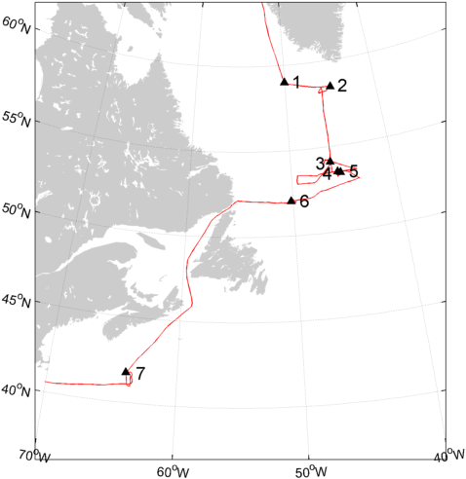

**Figure 1**. HiWinGS cruise track and the locations of primary measurement stations.

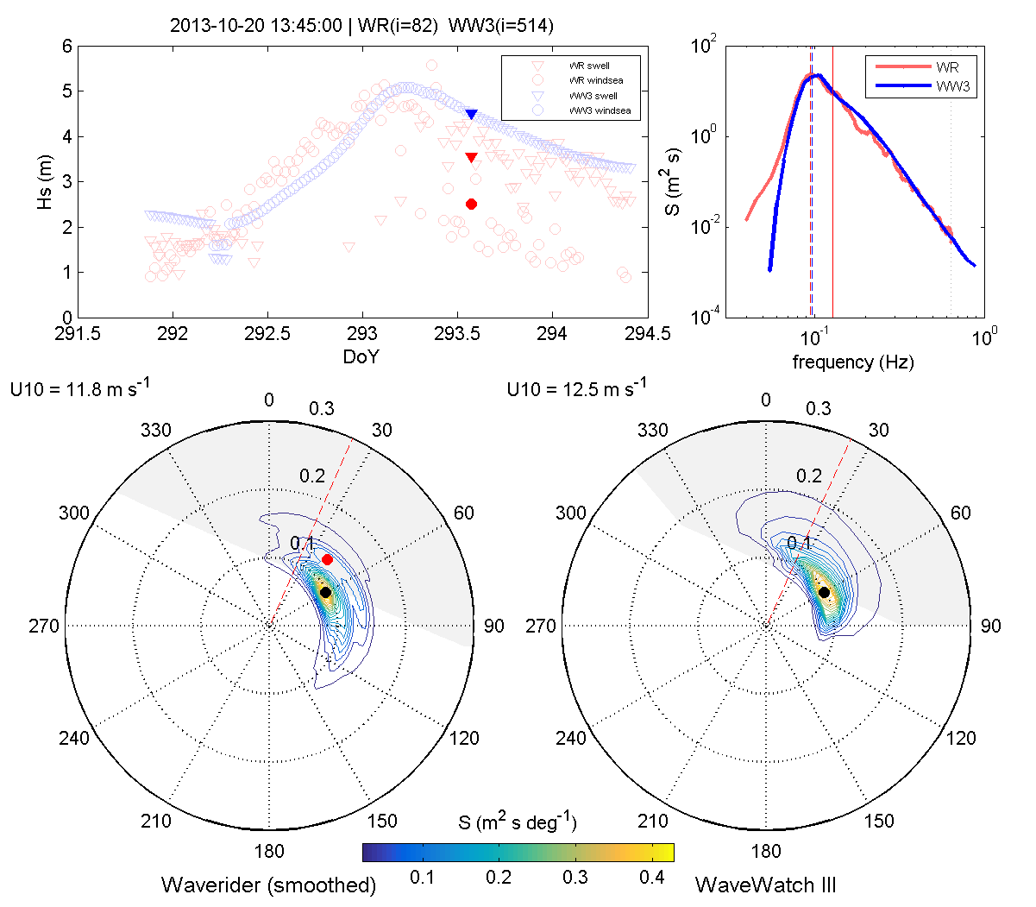

**Figure AA2**. Example directional wave spectra from the waverider and WAVEWATCH-III model for DoY = 293.573 (2013/10/20 13:45). The dashed red line indicates the wind direction for each; the grey shaded areas indicated the region in which spectral peaks are considered to be wind seas; red dots mark the peak of wind sea partition, black dots mark the peak of the swell partition.

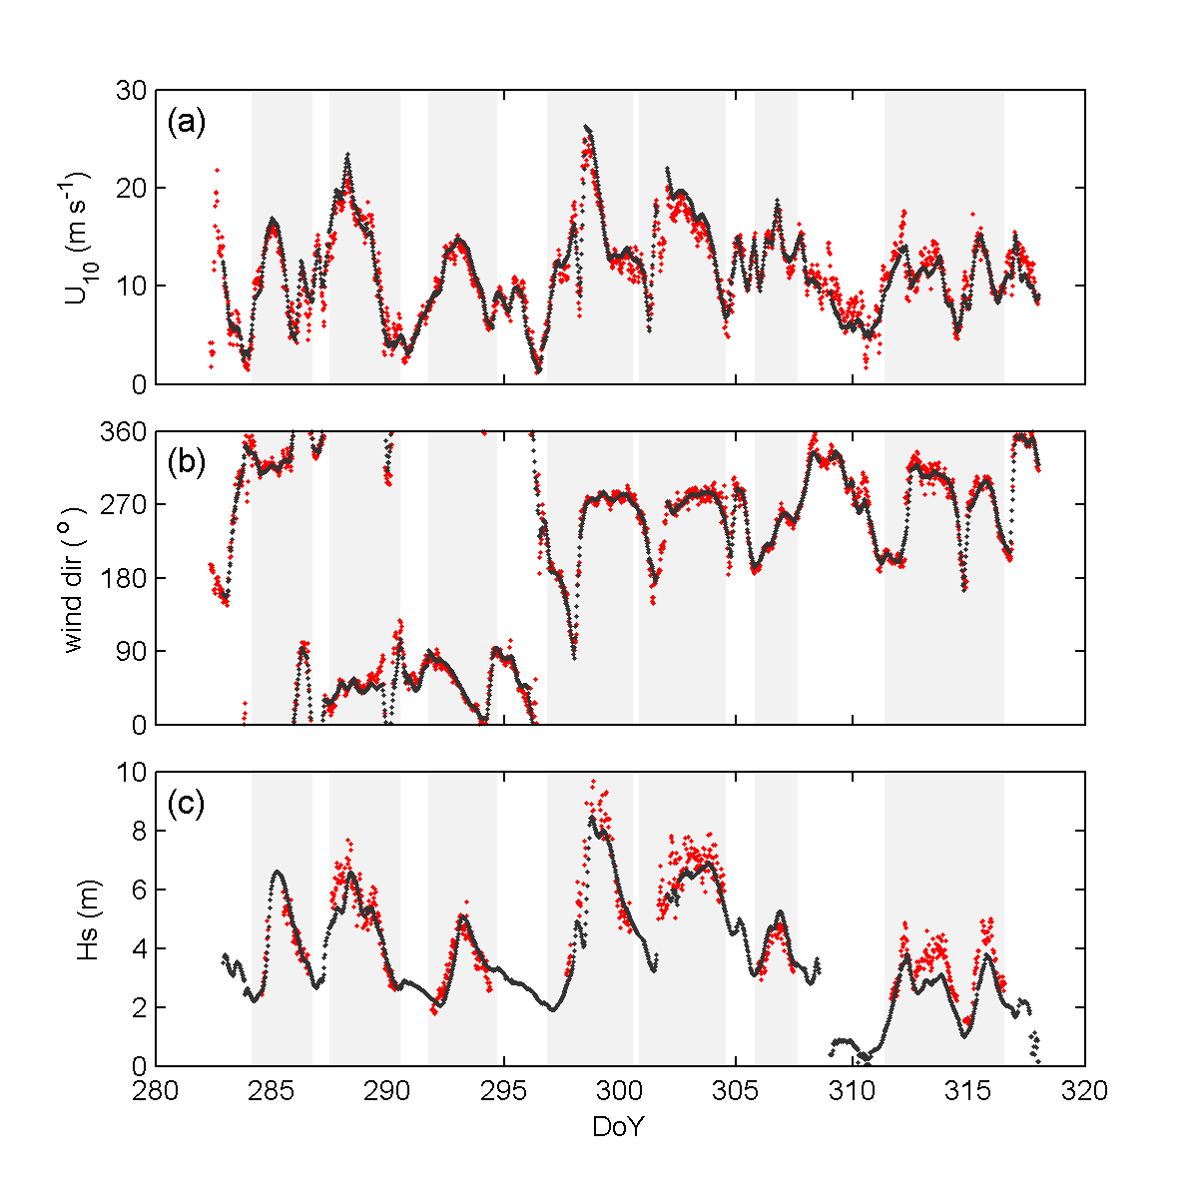

**Figure 2**. 30-minute average wind and wave conditions: (a) 10-m wind speed, (b) wind direction, (c) significant wave height. In each case the observed values are in red, the value from the WAVEWATCH model in black. The gray patches indicate the nominal times of each station during which the ship was hove to and buoys deployed.

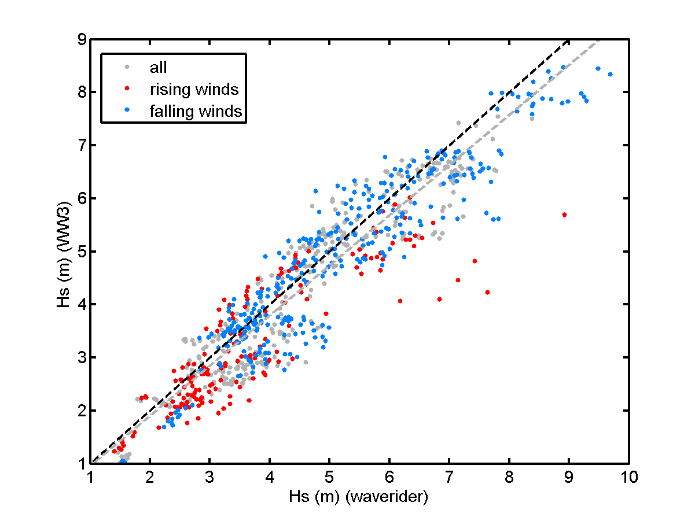

**Figure AA**. Significant wave height, Hs (m), from WAVEWATCH-III and the waverider. Points are partitioned by rising (red), falling (blue), and steady (grey) winds. The black dashed line is the 1:1 line, and the grey dashed line the best fit to the entire data set.

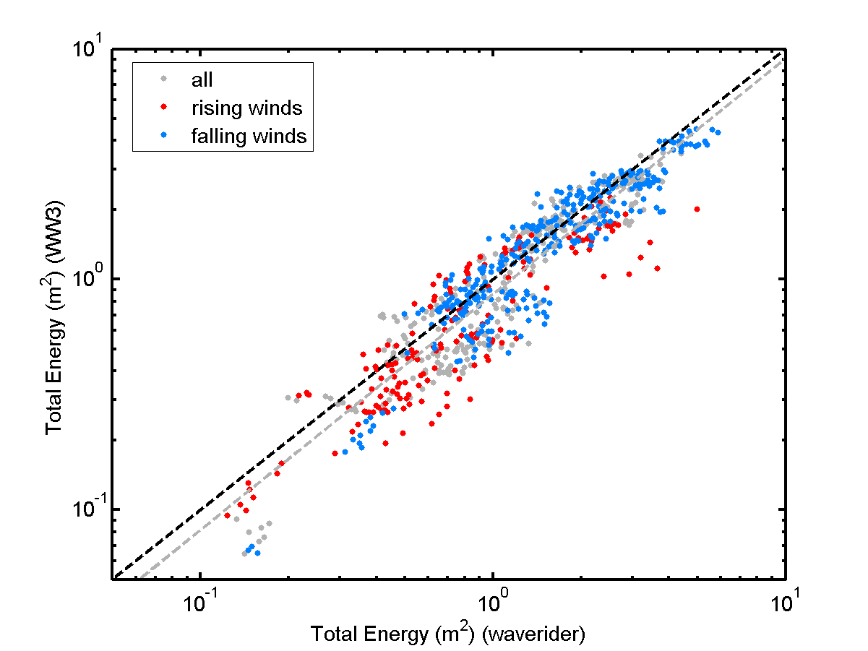

**Figure BB**. As figure 3, but for the total spectral energy over the common frequency range of the waverider and wave model. The grey dashed line is the linear best fit of log10(energy)

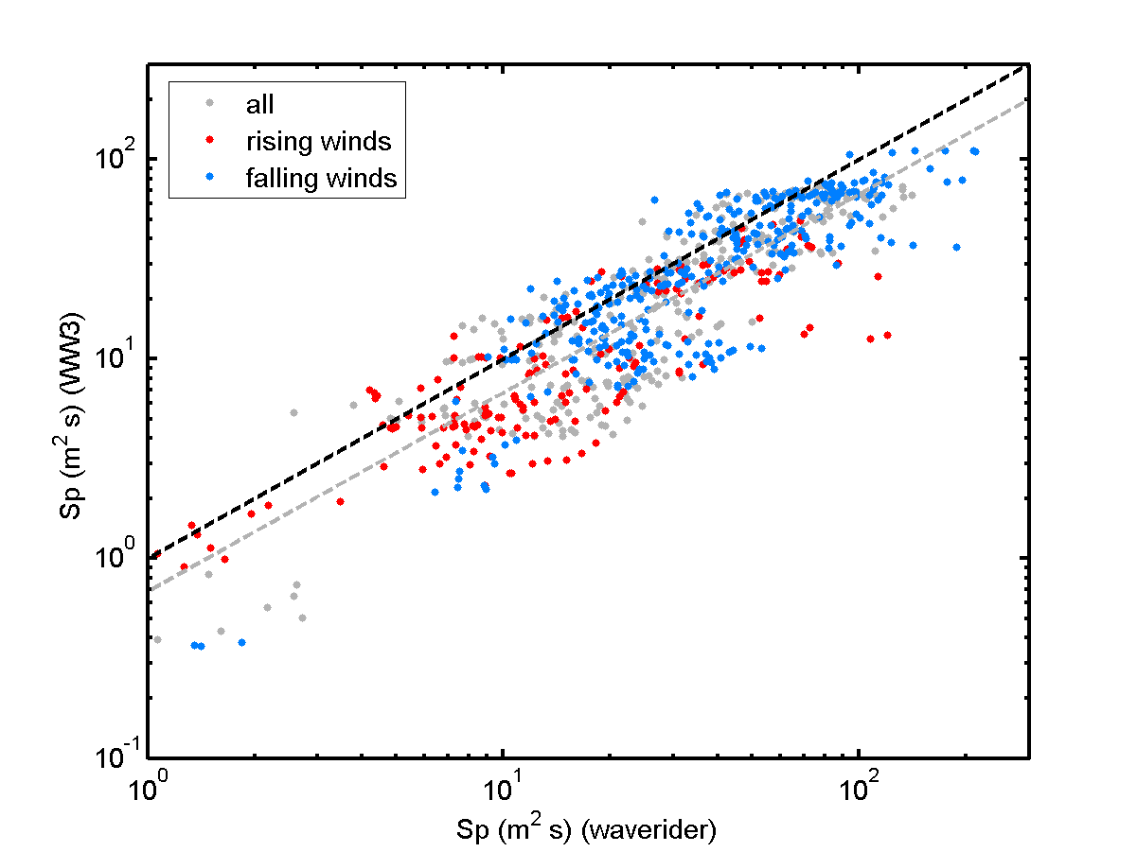

**Figure CC**. As figure 3 but for the energy at the (1D) spectral peak. The grey dashed line is the linear best fit of log10(Sp)

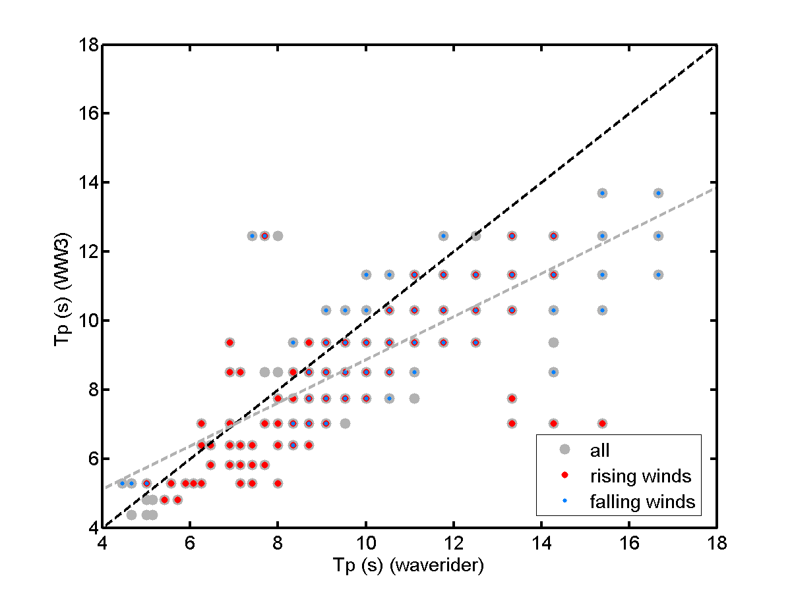

**Figure DD**. As figure 3 but for the period of the spectral peak.

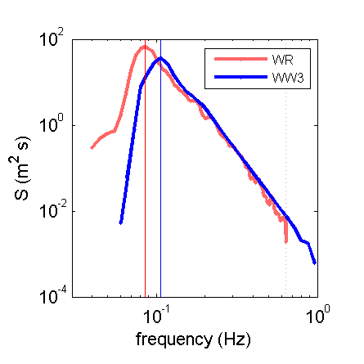

**Figure EE**. Example of typical 1-dimensional spectra close to the peak of the storm during station 3, at DoY = 288.0729 (2013/10/15 01:45). The solid vertical lines mark the frequencies of the spectral peaks; the dotted vertical line indicates the high frequency limit of the wverider, at which the WW3 spectra are truncated before calculating wave statistics. HsWW = 5.3 m, HsWR = 6.4 m; TpWW = 9.4 s, TpWR = 12.5 s; SpWW = 37.0 m2 s, SpWR = 71.6 m2 s.

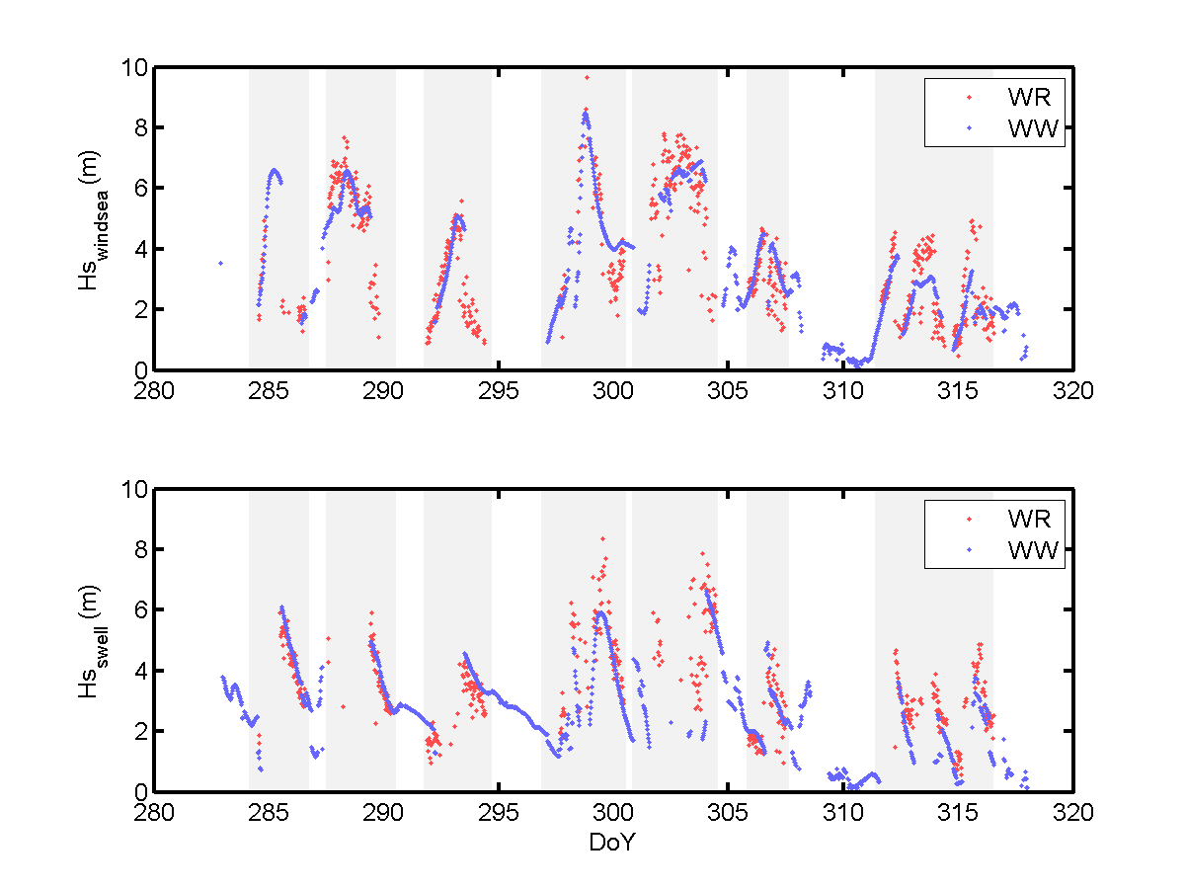

**Figure FF**. Time series of the significant wave height for the (a) wind sea, and (b) swell partitions of the directional wave spectra for the waverider and WW3. Grey patches indicate the nominal station times during which the waverider was deployed.

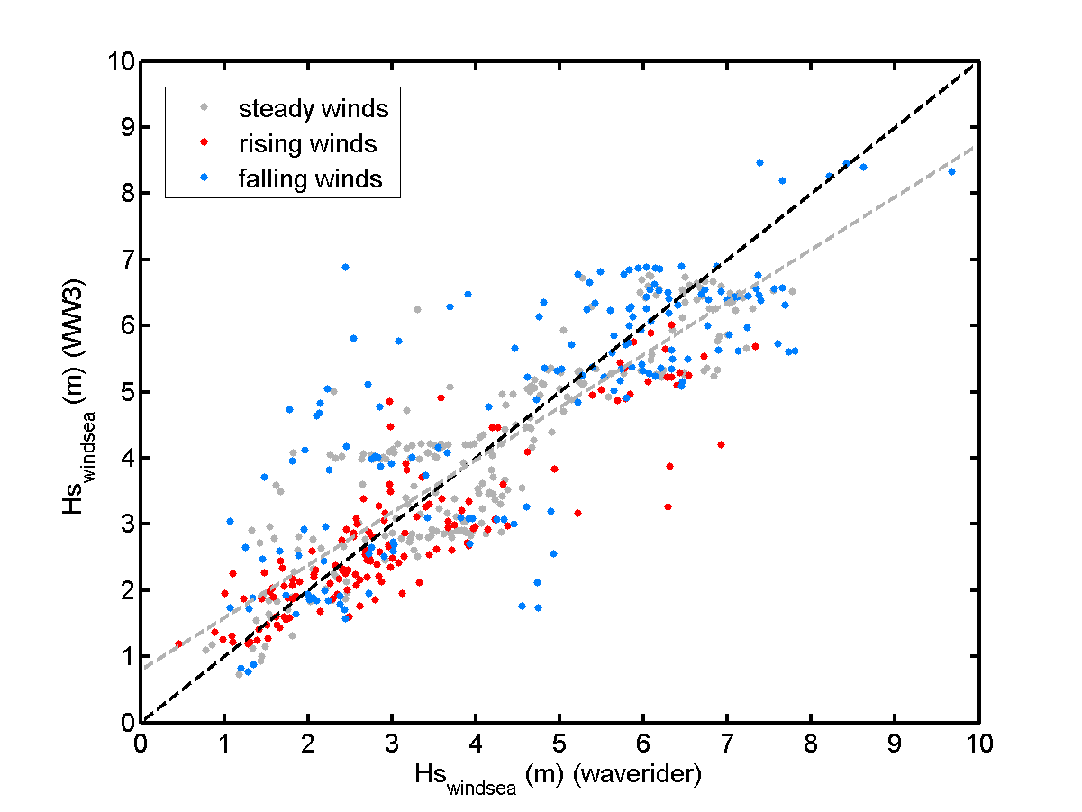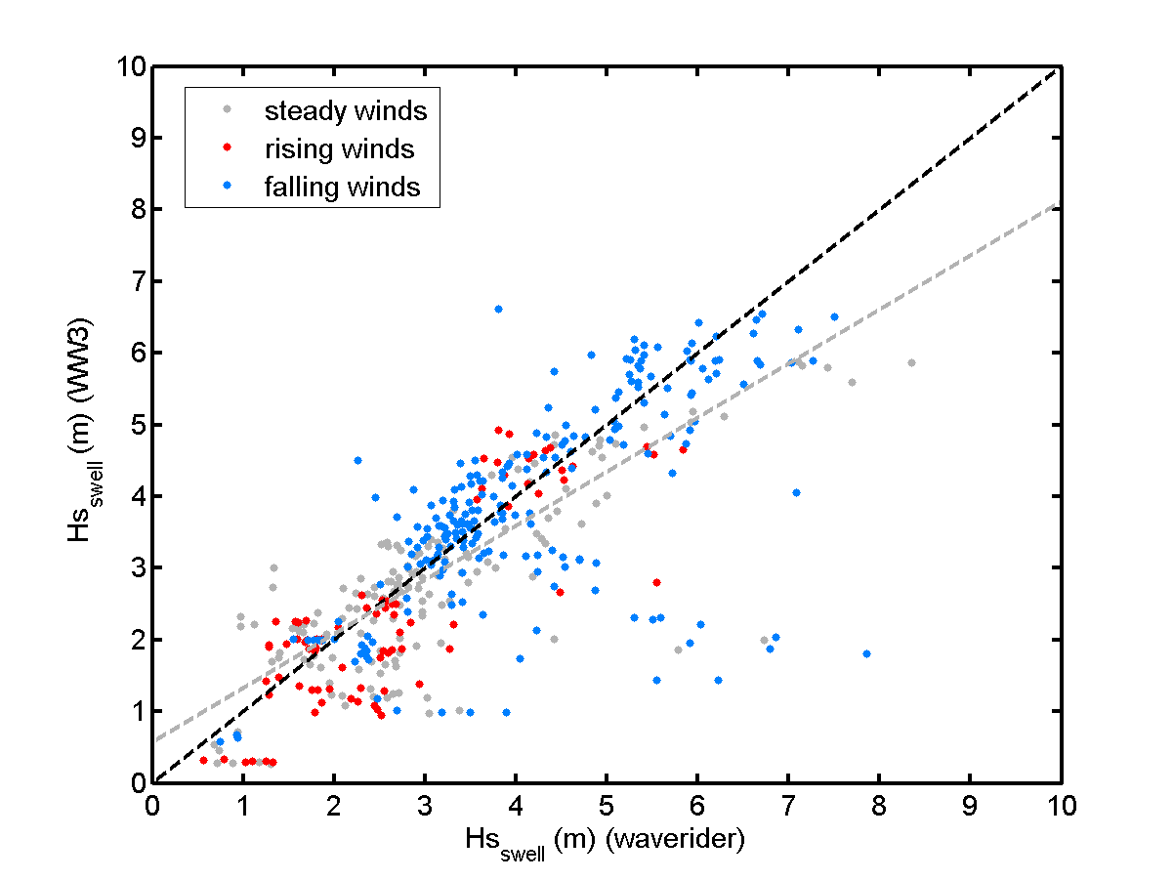

**Figure GG**. The significant wave height from (a) windsea and (b) swell wave partitions for times when they are identified in both the waverider and WW3 spectra. The grey dashed line is the best fit to all the points.

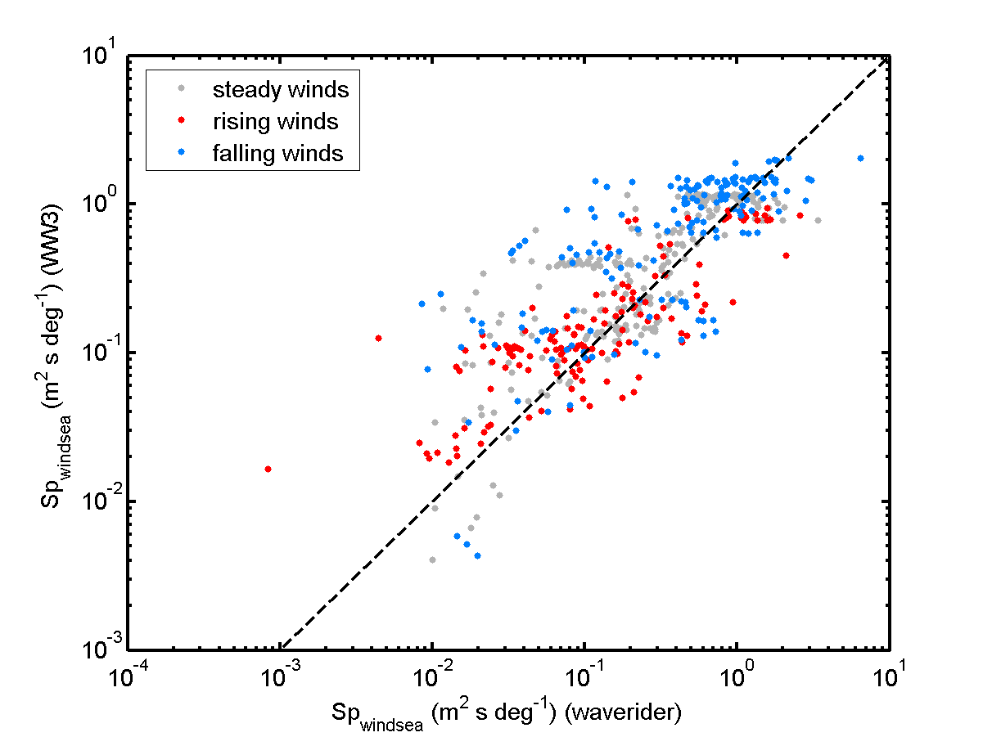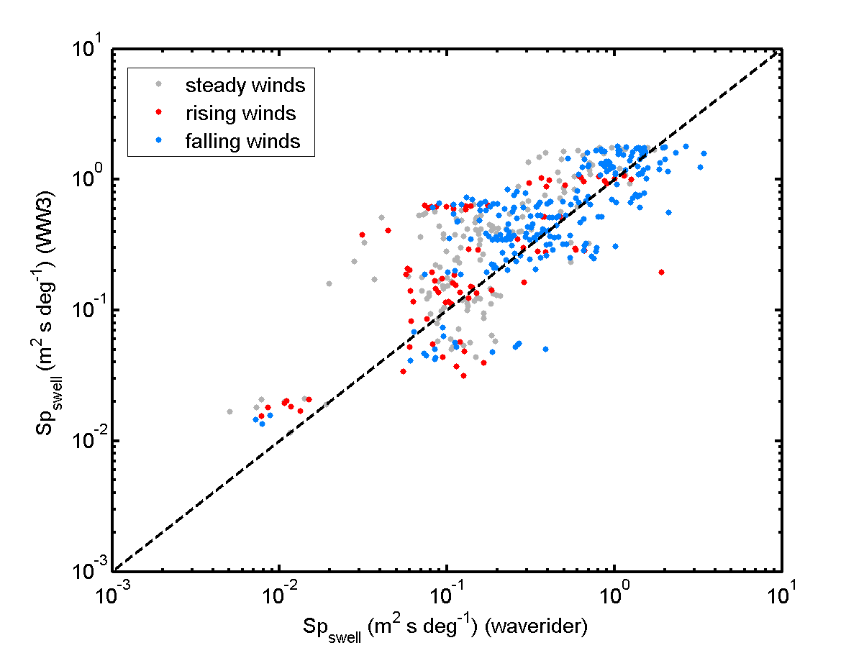

**FIGURE HH**. Energy density at the spectral peak of (a) wind sea and (b) swell wave partitions.

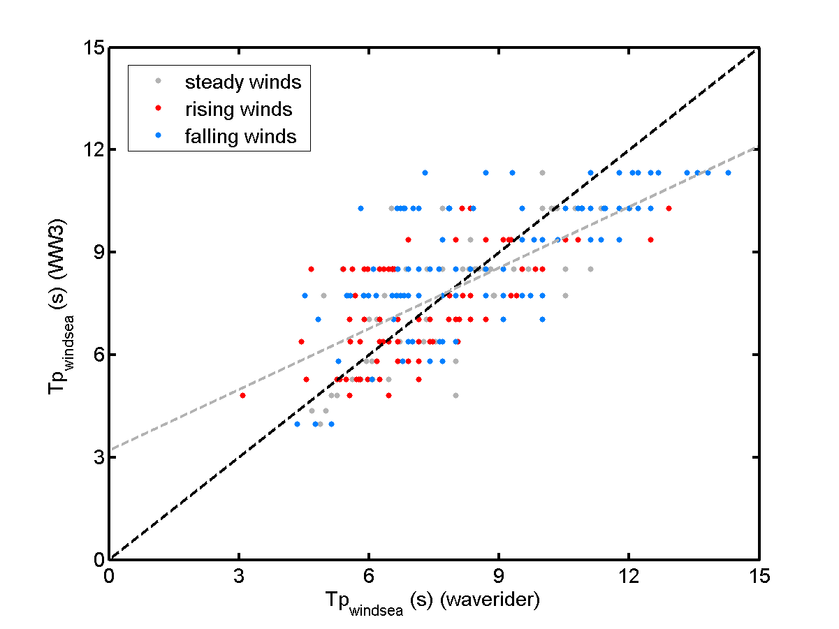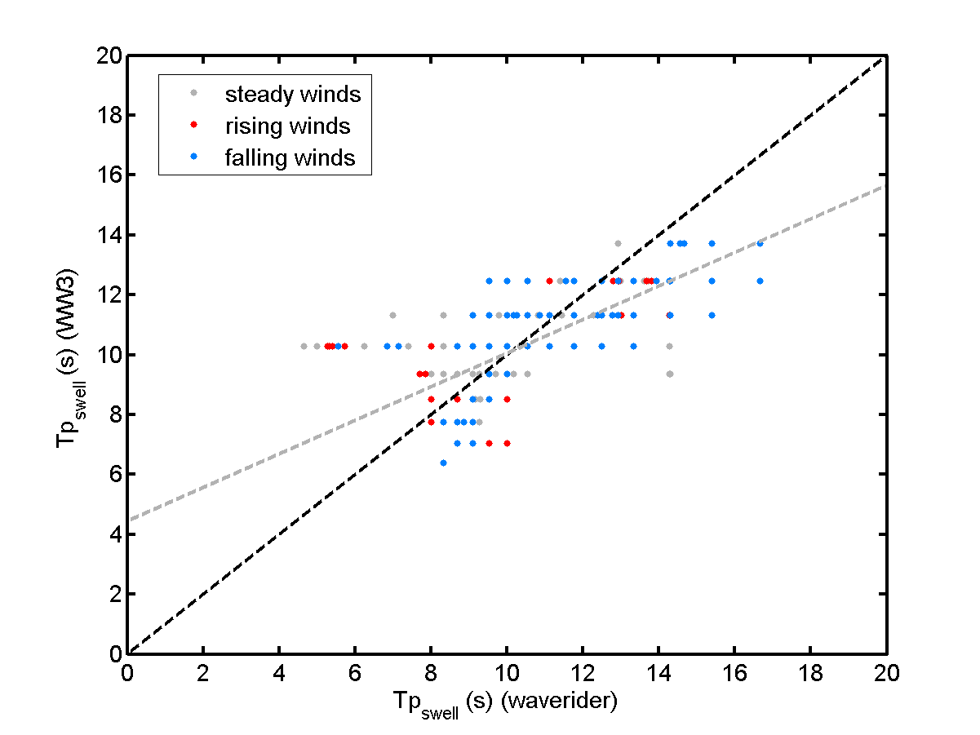

**Figure II**. Period of spectral peak for (a) wind sea and (b) swell wave partitions.

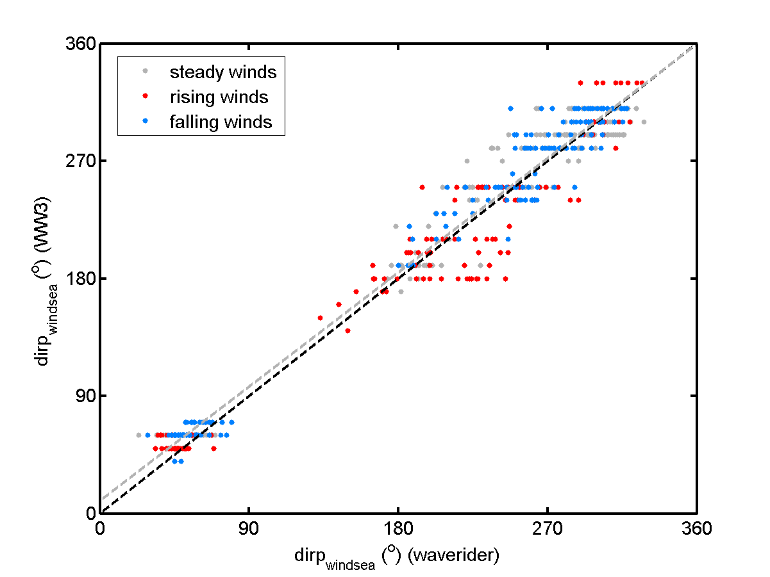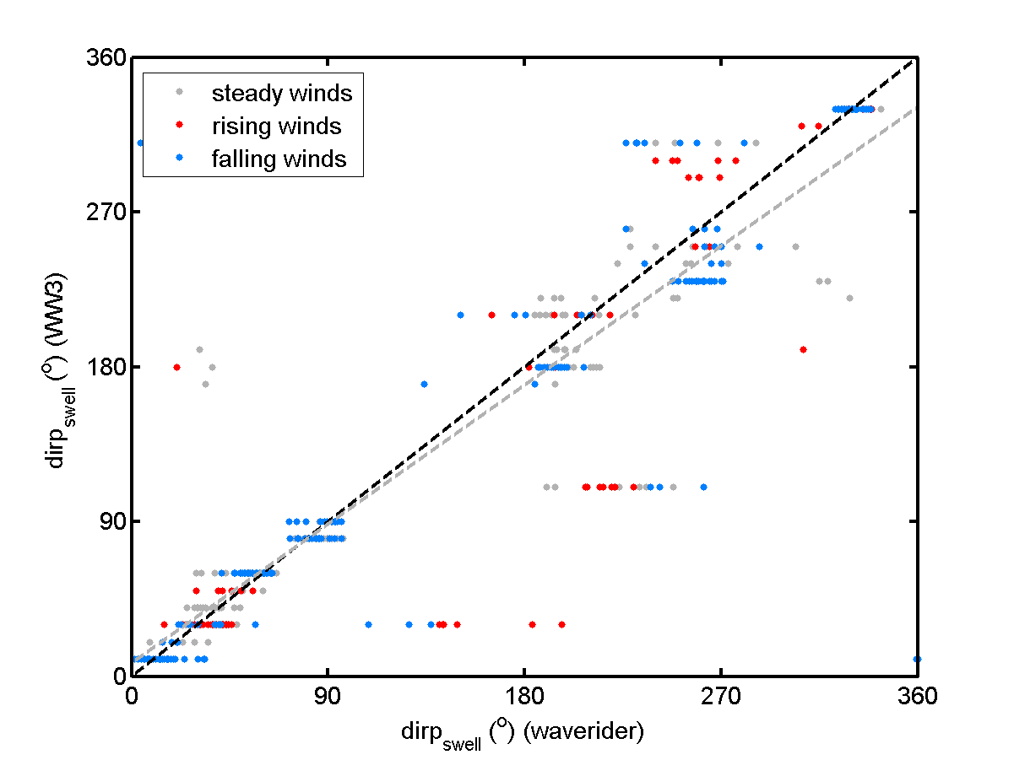

**Figure JJ**. Direction of wave peak for (a) wind sea and (b) swell wave partitions.

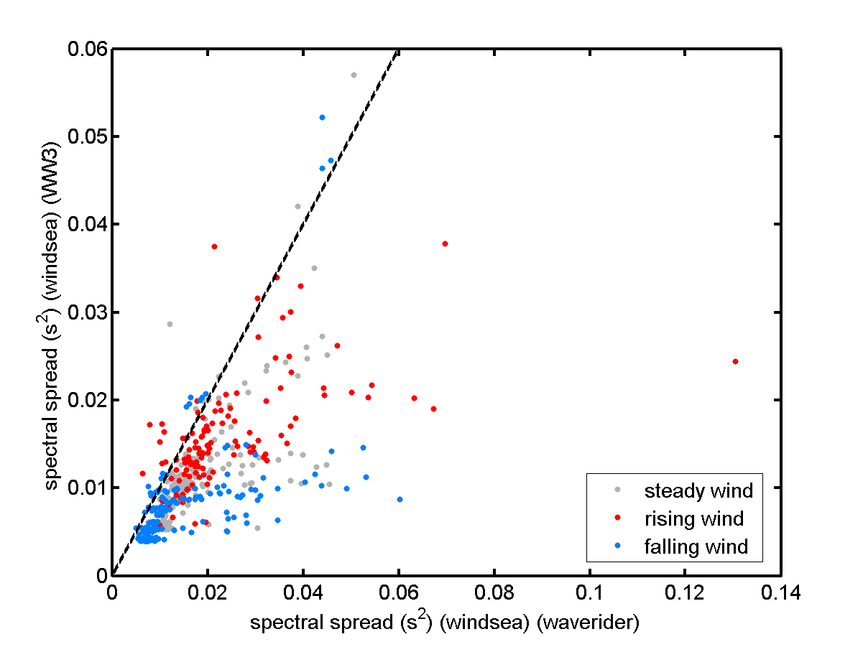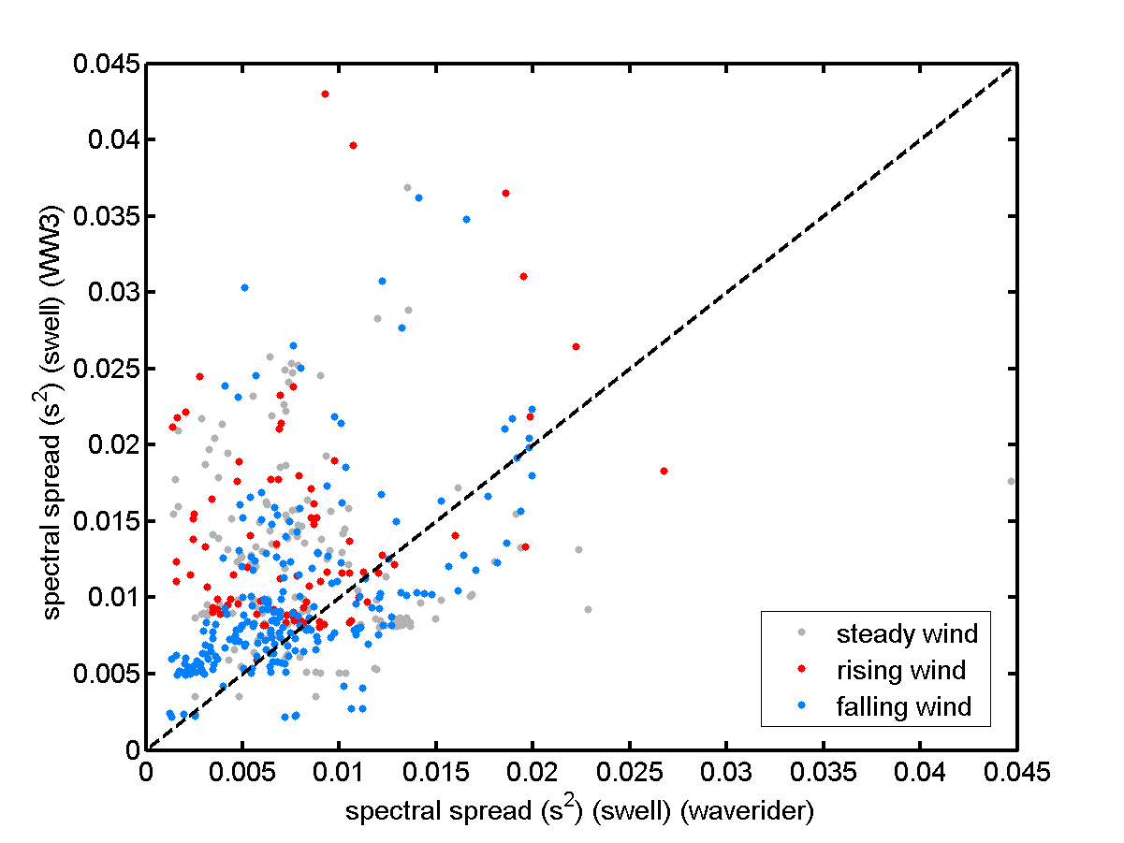

**Figure KK**. Spectral spreading for (a) wind sea wave partition (b) swell wave partition.